Video Library

Review the full library of videos here:
https://info.businessolver.com/video-library-resources-1

To embed on your layout, follow these instructions:
- Drag a Text Widget onto the layout.
- In the text widget, select the Source Code option in the editor
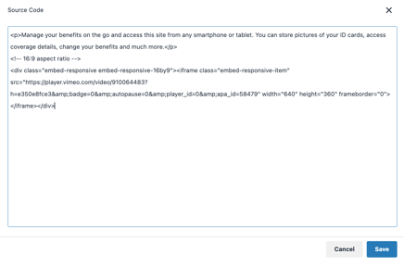
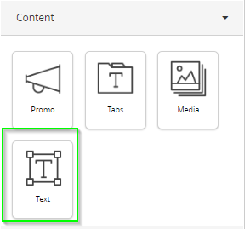
- Copy and paste the below embed code for the video you want placed there. Hit save twice.
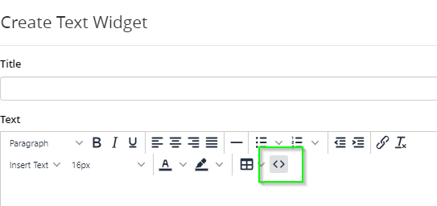

General Savings and Spending Accounts 2
MyChoice Accounts Member Videos 3
Voluntary Benefits Videos 4
General Benefitsolver Videos 6

General Savings and Spending Accounts
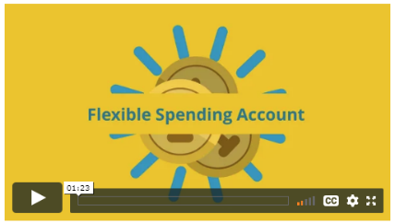
What is an FSA?
Copy and paste the below code:
<!-- 16:9 aspect ratio -->
<div class="embed-responsive embed-responsive-16by9"><iframe class="embed-responsive-item" src="https://player.vimeo.com/video/455910435" width="640" height="360" frameborder="0"></iframe></div>


What to Consider for an FSA
Copy and paste the below code:
<!-- 16:9 aspect ratio -->
<div class="embed-responsive embed-responsive-16by9"><iframe class="embed-responsive-item" src="https://player.vimeo.com/video/456731130" width="640" height="360" frameborder="0"></iframe></div>

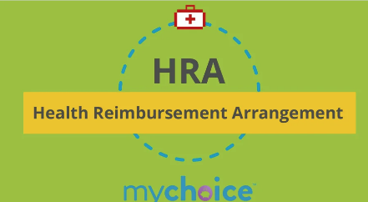
What is an HRA?
Copy and paste the below code:
<!-- 16:9 aspect ratio -->
<div class="embed-responsive embed-responsive-16by9"><iframe class="embed-responsive-item" src="https://player.vimeo.com/video/461993819" width="640" height="360" frameborder="0"></iframe></div>

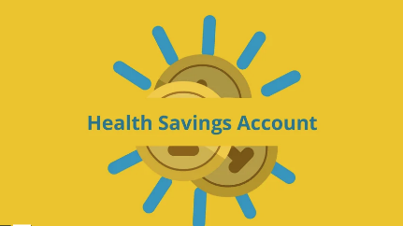
What is an HSA?
Copy and paste the below code:
<!-- 16:9 aspect ratio -->
<div class="embed-responsive embed-responsive-16by9"><iframe class="embed-responsive-item" src="https://player.vimeo.com/video/462397664" width="640" height="360" frameborder="0"></iframe></div>

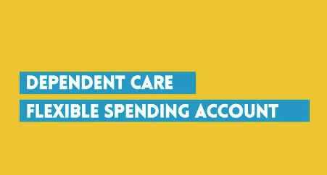
What is an DCFSA?
Copy and paste the below code:
<!-- 16:9 aspect ratio -->
<div class="embed-responsive embed-responsive-16by9"><iframe class="embed-responsive-item" src="https://player.vimeo.com/video/463053043" width="640" height="360" frameborder="0"></iframe></div>

MyChoice Accounts Member Videos
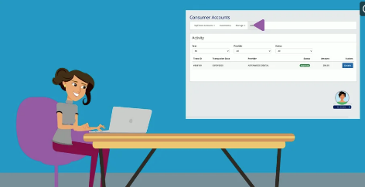
MyChoice Accounts Managing Your Account
Copy and paste the below code:
<!-- 16:9 aspect ratio -->
<div class="embed-responsive embed-responsive-16by9"><iframe class="embed-responsive-item" src="https://player.vimeo.com/video/461994152" width="640" height="360" frameborder="0"></iframe></div>


MyChoice Accounts: Accessing Your Funds
Copy and paste the below code:
<!-- 16:9 aspect ratio -->
<div class="embed-responsive embed-responsive-16by9"><iframe class="embed-responsive-item" src="https://player.vimeo.com/video/461994495" width="640" height="360" frameborder="0"></iframe></div>


Swipe and Save with your FSA
Copy and paste the below code:
<!-- 16:9 aspect ratio -->
<div class="embed-responsive embed-responsive-16by9"><iframe class="embed-responsive-item" src="https://player.vimeo.com/video/ 592860780" width="640" height="360" frameborder="0"></iframe></div>

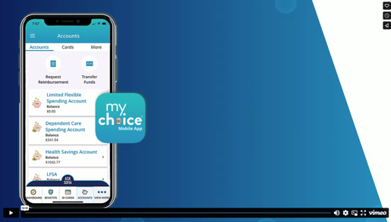
MyChoice Accounts: Member Mobile App Demo
Copy and paste the below code:
<!-- 16:9 aspect ratio -->
<div class="embed-responsive embed-responsive-16by9"><iframe class="embed-responsive-item" src="https://player.vimeo.com/video/846017323" width="640" height="360" frameborder="0"></iframe></div>

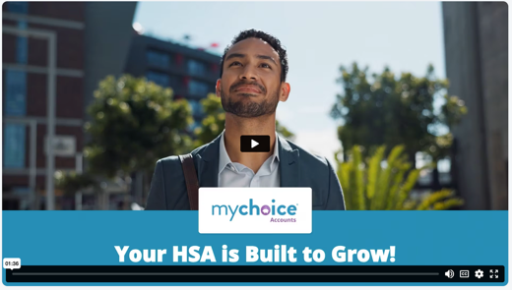
MyChoice Accounts HSA: HSA Investments
Copy and paste the below code:
<!-- 16:9 aspect ratio -->
<div class="embed-responsive embed-responsive-16by9"><iframe class="embed-responsive-item" src="https://player.vimeo.com/video/892651023" width="640" height="360" frameborder="0"></iframe></div>

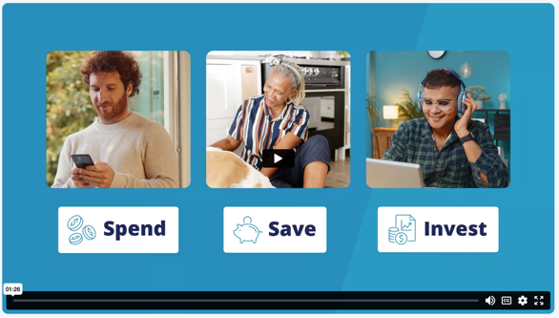
MyChoice Accounts HSA: Spend, Save, and Invest

Copy and paste the below code:
<!-- 16:9 aspect ratio -->
<div class="embed-responsive embed-responsive-16by9"><iframe class="embed-responsive-item" src=" src="https://player.vimeo.com/video/1112982694" width="640" height="360" frameborder="0"></iframe></div>

Voluntary Benefits Videos


Accident insurance
Copy and paste the below code:
<!-- 16:9 aspect ratio -->
<div class="embed-responsive embed-responsive-16by9"><iframe class="embed-responsive-item" src=https://player.vimeo.com/video/460397509 width="640" height="360" frameborder="0"></iframe></div>


Hospital Indemnity
Copy and paste the below code:
<!-- 16:9 aspect ratio -->
<div class="embed-responsive embed-responsive-16by9"><iframe class="embed-responsive-item" src=https://player.vimeo.com/video/461124877 width="640" height="360" frameborder="0"></iframe></div>


Critical Illness
Copy and paste the below code:
<!-- 16:9 aspect ratio -->
<div class="embed-responsive embed-responsive-16by9"><iframe class="embed-responsive-item" src=https://player.vimeo.com/video/461066479 width="640" height="360" frameborder="0"></iframe></div>


ID Theft
Copy and paste the below code:
<!-- 16:9 aspect ratio -->
<div class="embed-responsive embed-responsive-16by9"><iframe class="embed-responsive-item" src=https://player.vimeo.com/video/460610867 width="640" height="360" frameborder="0"></iframe></div>

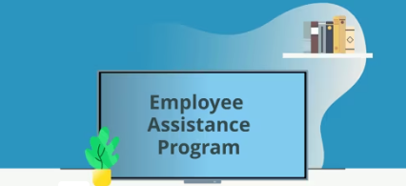
EAP

Copy and paste the below code:
<!-- 16:9 aspect ratio -->
<div class="embed-responsive embed-responsive-16by9"><iframe class="hs-responsive-embed-iframe" style="position: absolute; top: 0; left: 0; width: 100%; height: 100%; border: none;" allow="autoplay; fullscreen" xml="lang" src="//player.vimeo.com/video/456267722?title=0&amp;byline=0&amp;portrait=0&amp;color=8dc7dc" width="900" height="506" frameborder="0" allowfullscreen="" data-service="vimeo"></iframe></div>

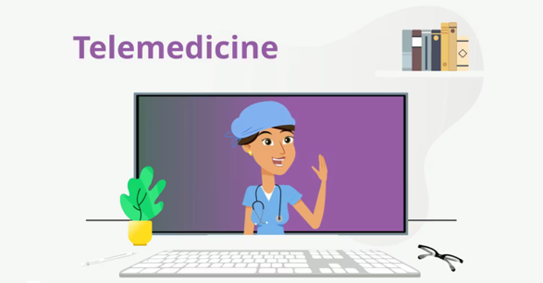
Telemedicine
Copy and paste the below code:
<!-- 16:9 aspect ratio -->
<div class="embed-responsive embed-responsive-16by9"><iframe class="hs-responsive-embed-iframe" style="position: absolute; top: 0; left: 0; width: 100%; height: 100%; border: none;" allow="autoplay; fullscreen" xml="lang" src="https://player.vimeo.com/video/460285266?badge=0&amp;autopause=0&amp;player_id=0&amp;app_id=58479" width="900" height="506" frameborder="0" allowfullscreen="" data-service="vimeo"></iframe></div>
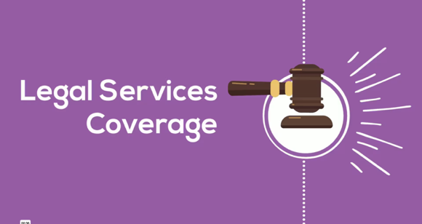
Legal
Copy and paste the below code:
<div class="embed-responsive embed-responsive-16by9"><iframe class="hs-responsive-embed-iframe" style="position: absolute; top: 0; left: 0; width: 100%; height: 100%; border: none;" allow="autoplay; fullscreen" xml="lang" src="https://player.vimeo.com/video/461126014?badge=0&amp;autopause=0&amp;player_id=0&amp;app_id=58479" width="900" height="506" frameborder="0" allowfullscreen="" data-service="vimeo"></iframe></div><!-- 16:9 aspect ratio -->

General Benefitsolver Videos
Sofia
Copy and paste the below code:
<p>Available 24/7, Sofia&trade; is your virtual benefits assistant. Whether you need help understanding your medical plan or assistance navigating the site, you can always chat with her.</p>
<!-- 16:9 aspect ratio -->
<div class="embed-responsive embed-responsive-16by9"><iframe class="embed-responsive-item" src="https://player.vimeo.com/video/454522952" width="640" height="360" frameborder="0"></iframe></div>


Decision Support (formerly “MyChoice Recommendation Engine”)
Copy and paste the below code:
<p>Enroll using the decision support tool to get guidance when choosing the right benefits. Answer a few questions about your health and lifestyle, and you will receive a personalized recommendation.</p>
<!-- 16:9 aspect ratio -->
<div class="embed-responsive embed-responsive-16by9"><iframe class="embed-responsive-item" src="https://player.vimeo.com/video/452265325" width="640" height="360" frameborder="0"></iframe></div>
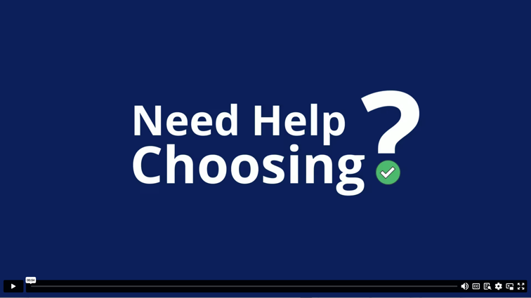

MyChoice Mobile App – without MyChoice Accounts
Copy and paste the below code:
<p>Manage your benefits on the go and access this site from any smartphone or tablet. You can store pictures of your ID cards, access coverage details, change your benefits and much more.</p>
<!-- 16:9 aspect ratio -->
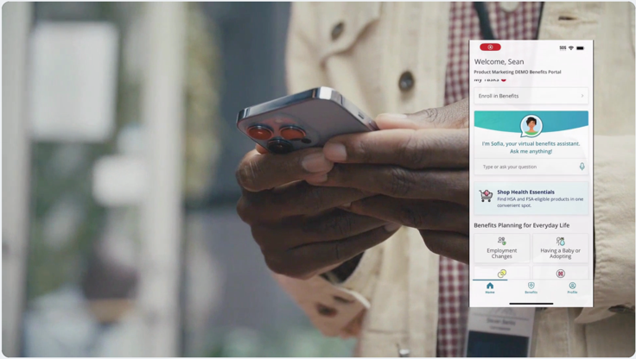
<div class="embed-responsive embed-responsive-16by9"><iframe class="embed-responsive-item" src="https://player.vimeo.com/video/453420209?app_id=122963" width="640" height="360" frameborder="0"></iframe></div>

MyChoice Mobile App – with MyChoice Accounts
<p>Manage your benefits on the go and access this site from any smartphone or tablet. You can store pictures of your ID cards, access coverage details, change your benefits and much more.</p>
<!-- 16:9 aspect ratio -->
<div class="embed-responsive embed-responsive-16by9"><iframe class="embed-responsive-item" src="https://player.vimeo.com/video/910064483?h=e350e8fce3&amp;badge=0&amp;autopause=0&amp;player_id=0&amp;apa_id=58479" width="640" height="360" frameborder="0"></iframe></div>
