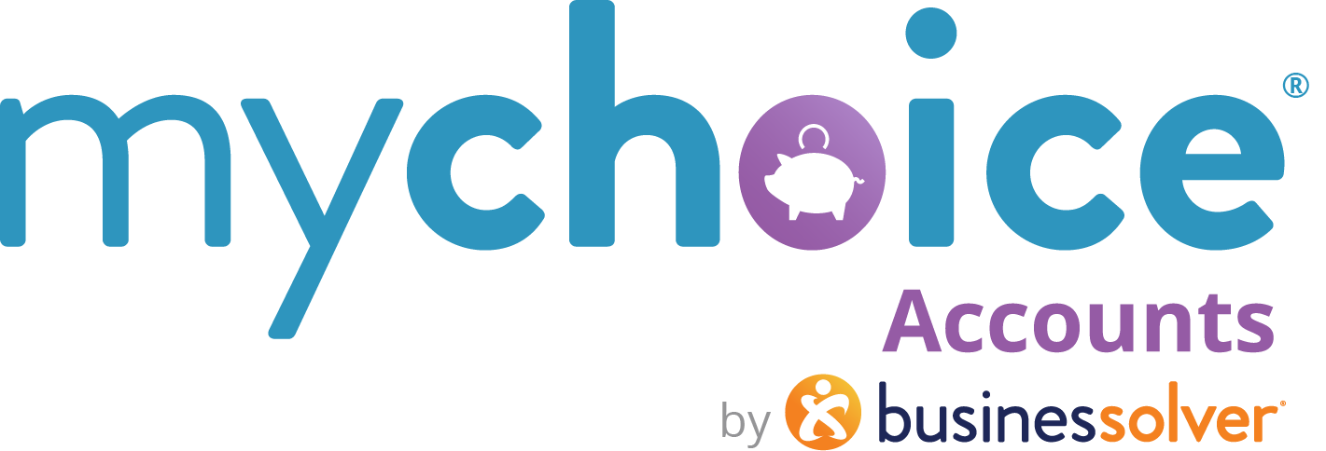

Health Savings Accounts
HSAs

How to use this document:
- If you need to populate a benefits guide, web page, or virtual benefits fair, feel free to pull the relevant copy from this guide.
- Items that are client-level/client-specific plan designs are marked in yellow. Ensure your client-specific information is updated in those fields.

MyChoice Accounts: Health Savings Accounts
How an HSA can benefit you and your wallet
Whether you are a Health Savings Account (HSA) noob or a seasoned account holder, brush up on best practices for using your account.

Just the basics
An HSA is a short-term or long-term tax-free saving for eligible out-of-pocket health care expenses. The account belongs to you and grows year over year. You maintain ownership, even if you leave the organization. HSA money is yours to spend on current costs or save, or invest for future health care expenses.
Translation: Create a rainy-day fund for future costs.
Contributions

<Company name> contributes $XXX for individual or $X,XXX for family
(add details about the timing of your seed contributions)
It's like free money!

How much can I contribute each year?
You may contribute as little as {$1} up to a maximum total (including company contributions):
- $4.400 for individual in 2026
- $8,750 for family in 2026
- Age 55+ can contribute an extra $1,000 as a catch-up contribution amount

How do I access my HSA funds?
- Use your MyChoice Accounts Visa debit card at your provider, lab, hospital, or retailer or use it to pay your eligible medical bills.
- If you don’t have your card handy, you may submit a request for a reimbursement through {your Benefitsolver URL} or the MyChoice Mobile App.

Options for Saving and Investing
Did you know that your HSA dollars can work for you? You have the option to save part of your HSA in a money market fund for predictable dividends, or you can also invest your HSA funds in low-cost funds for higher potential returns We recommend you keep at least {{$1,000}} in your available HSA to spend in case of a medical emergency. However, you can save or invest your funds that you don’t plan to spend in the near future. In your online benefits portal, go to Investments to get started. Investments are self-directed and subject to market fluctuations. You can sell your investments at any time.

Eligible Expenses
Review a list of common eligible expenses
(list hyperlink: https://businessolver.com/mychoice-accounts/eligible-expenses/)

Bookmark This
If you have questions throughout the year about your HSA, check out these online resources // LEARN MORE
(learn more hyperlink: https://www.businessolver.com/mychoice-accounts/participants/health-savings-account)
(If your company offers both a HCFSA and an HSA, here’s a quick quiz for your members)
Save time and money with the HSA Store
If you need to stock up your family first aid cabinet, get some over-the-counter items like medicine, insoles, baby monitors, and more…check out the HSA Store. Everything there is 100% verified and an HSA-eligible item.
Here’s a coupon for $5 off. Use it at the HSA Store with code 5OFFBSC at checkout.


(Cut and paste the coupon or download here.)

