Member HSA Webinar Promotion and Details
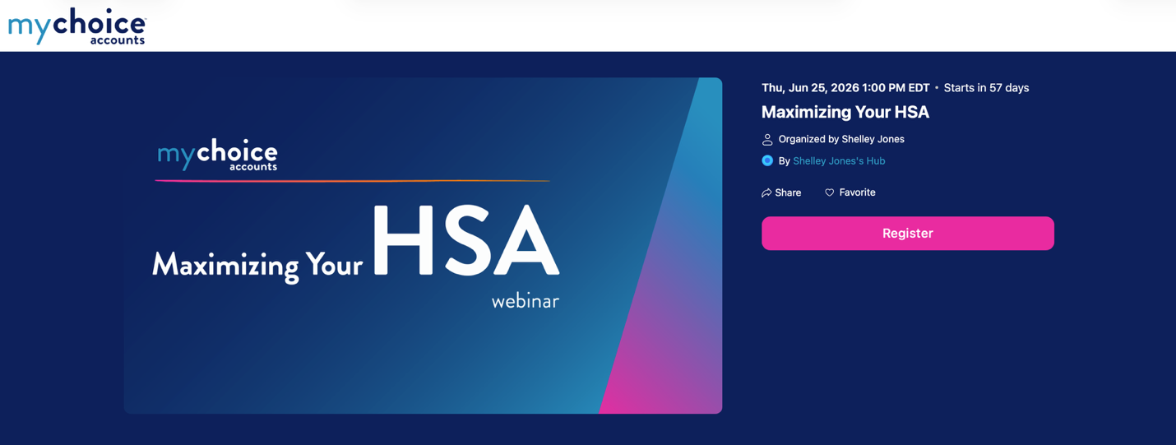

MyChoice Accounts is hosting an all-HSA member webinar on

June 25, from 12 – 12:45 p.m. CT.

Member/Attendee Registration: Maximizing Your HSA

This event will be for any member enrolled in an HSA. Client admins are also welcome to attend.

Get all the details on how to best use your HSA, whether you're a spender, a saver, an investor...or are still trying to figure it out!

Find out the basics of your account, how to access your funds, details on your investment options...and more.
We’ll also peek into MyChoice Accounts online and see how to navigate and use the system.

(investment advice will not be provided, only navigation and information about options)

Format: Zoom Webinar – with Q & A and team to answer questions; recorded to provide to employees via Benefitsolver or direct video link

Sign up: Pre-Registration to help us gauge attendance and to provide a one-day and an hour-before reminder to registrants.

How to Promote
- System Emails: There are system emails available if you would like to work with your CSL to deploy those to active HSA members.
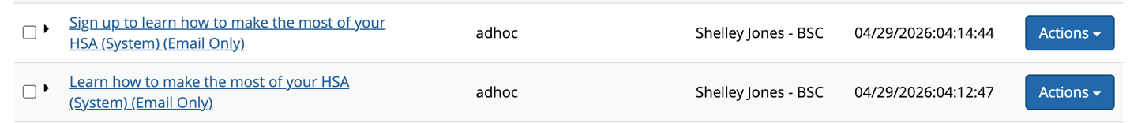

- Use Copy or Share Link: Or, you are welcome to share the registration link and/or use the Word copy below.

https://events.zoom.us/ev/AjMg_-EKIAGd1ZTAJxuofICqY7tp8HReXg0lT_tV-n1-7jI9mlLL~AuxZ6_MebWyjRNzW4ZekkQnTrClqZcIcdG-JNEuls9piYx1_ar-r7vxJuw

Download a slide/digital poster for the webinar with a QR code.
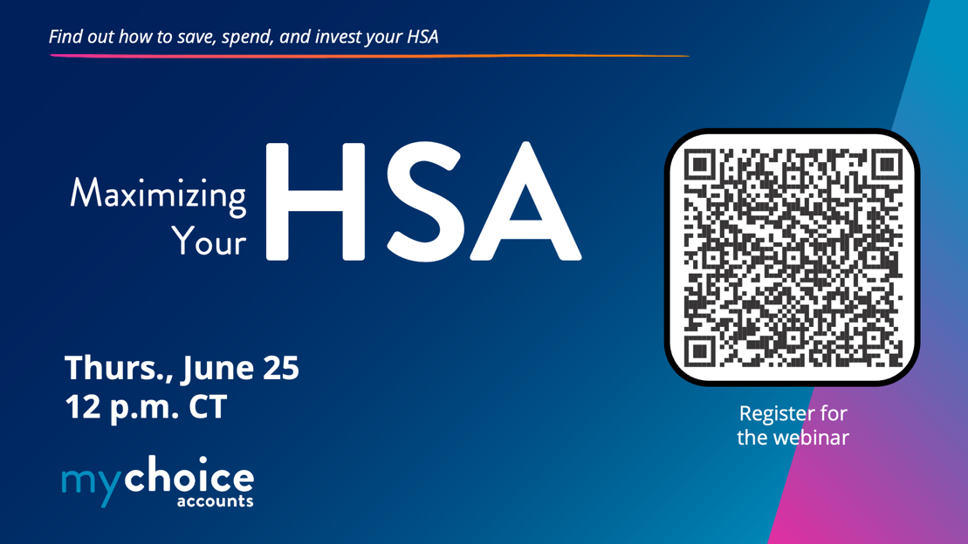

Email 1
Timing: three weeks out
Subject: Learn how to make the most of your HSA
Hello:
Did you know you are enrolled in a powerful savings account? Yes! Your health savings account (HSA) is a great way to save on everyday expenses and save for future needs. Join this webinar from the team at MyChoice Accounts for more information about your HSA.
Learn all about:
- What’s covered and how an HSA works.
- Easy ways to pay for eligible expenses.
- Investment options.
Date: June 25
Time: 12 p.m. CT
Reserve your spot and make sure you know how to set up your HSA for success.

Register here
We hope you take advantage of this opportunity to learn more about HSAs.

**********************************************************************

Email 2
Timing: one week out
Subject: Are you ready to maximize your HSA?
Hello:
The team at MyChoice Accounts is gearing up for an informational webinar that will help you increase your HSA knowledge so you can save money on your healthcare costs and make sure you’re ready for future health care needs.
Join their upcoming webinar to learn more about:
- What’s included and how an HSA works.
- The best way to get reimbursed.
- Investments that help your account grow.

Date: June 25, 2026

Time: 12 p.m. CT
Don’t miss this chance to learn how to cover your healthcare expenses—now and later.

Register here

P.S. Can’t attend? Just register and the team at MyChoice Accounts will send you the recording.

