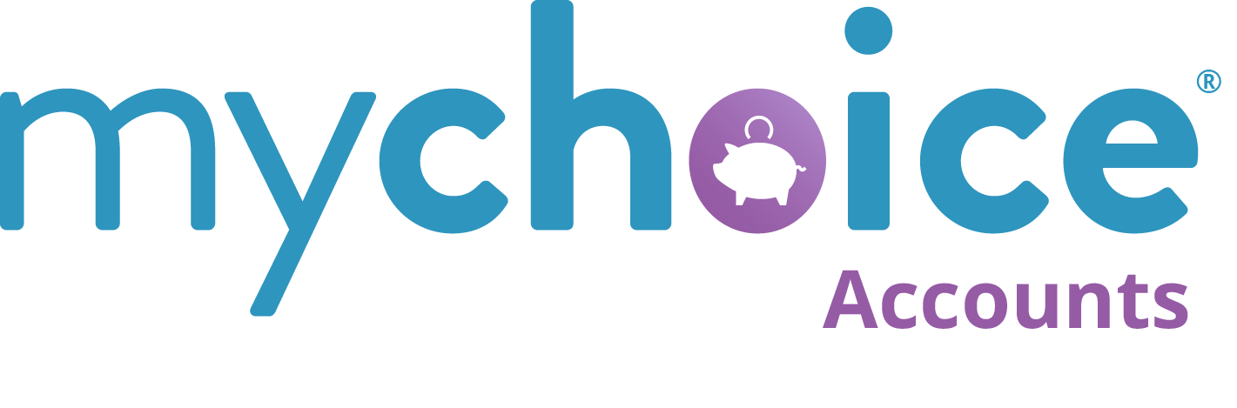

Enrollment Reminders 2026
Use the system templates in Benefitsolver or Word document copy to send out enrollment reminders or to make sure that employees who are eligible but unenrolled understand their benefits.

HSA 2
System template name: Consider enrolling in an HSA 2
HSA 3
System Template Name: Get ready to re-enroll in your HSA 3
FSA 4
System template name: Consider enrolling in an FSA 4
FSA 5
System Template name: Get ready to enroll in your Health Care FSA 5
Dependent Care FSA 6
System Template Name: Save Big with a Dependent Care FSA 6
Dependent Care FSA 7
System Template Name: Get ready to enroll in your Dependent Care FSA 7
Word Version: HSA 9
Unenrolled, eligible for HSA employees – “Don’t Miss Out on Savings” 9
Word Version: HSA 10
All current members – Get Ready to Enroll 10
Word Version: FSA 11
Employees who are NOT enrolled – Start Saving in 2026! 11
Word Version: FSA 12
All current members– Get Ready to Enroll 12
Word Version: DCFSA 13
DCFSA: Employees who are NOT enrolled – Start Saving in 2026! 13
Word Version: DCFSA 14
All current members– Get Ready to Enroll 14

HSA

System template name: Consider enrolling in an HSA

Send to unenrolled, but eligible (probably already are enrolled in an HDHP)
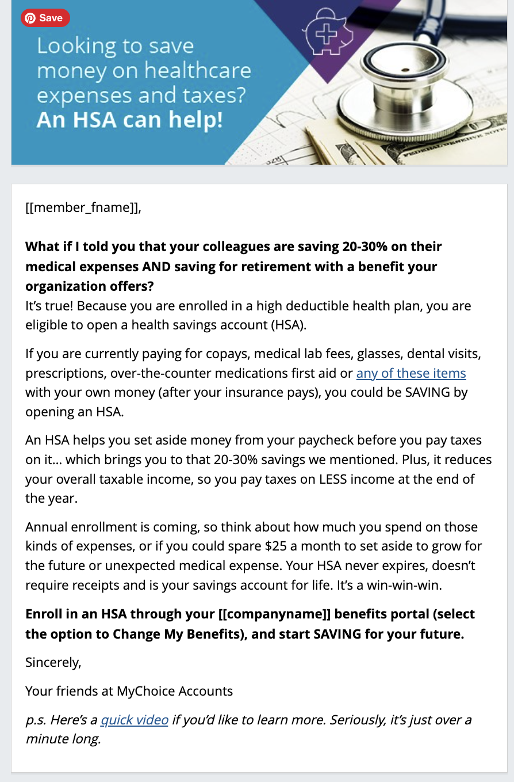

HSA

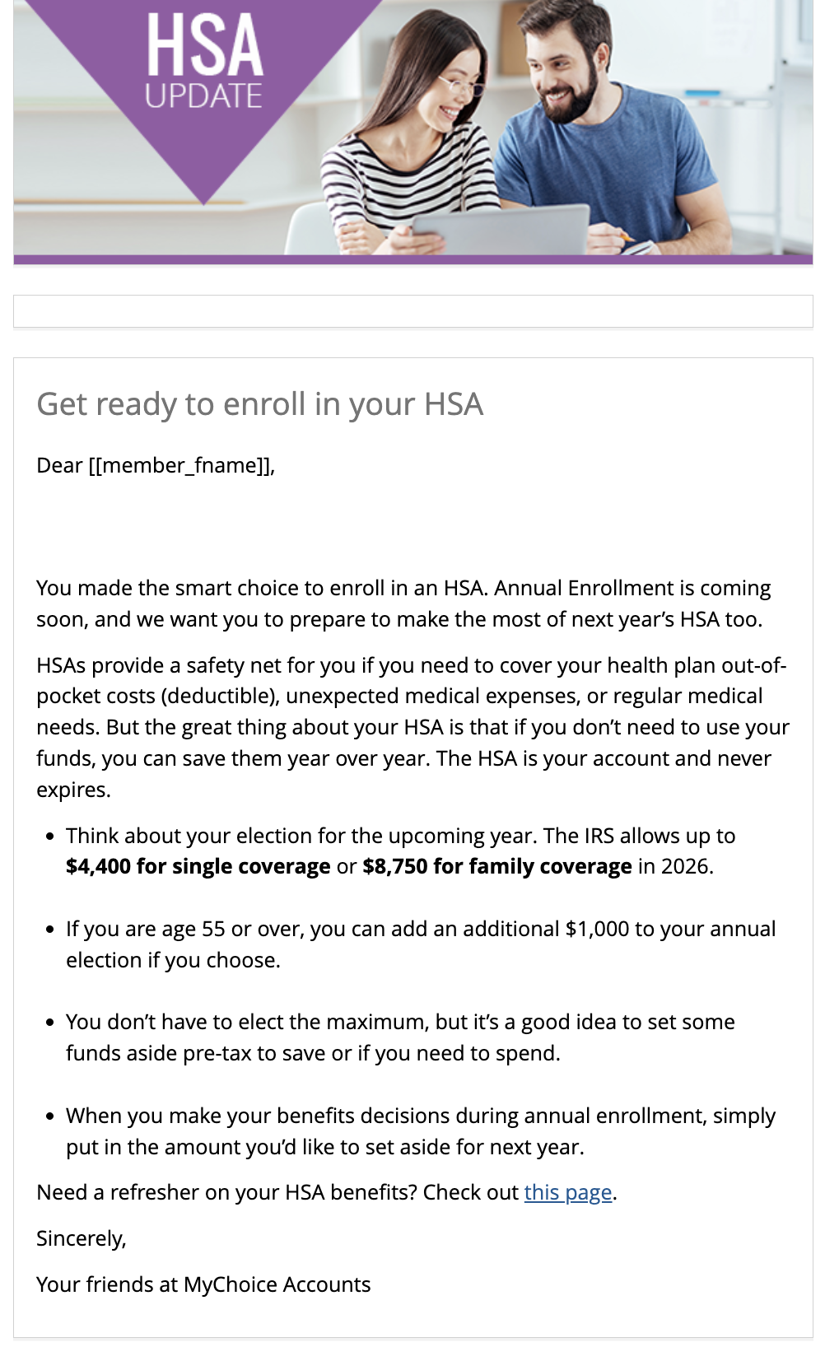
System Template Name: Get ready to re-enroll in your HSA

FSA

System template name: Consider enrolling in an FSA

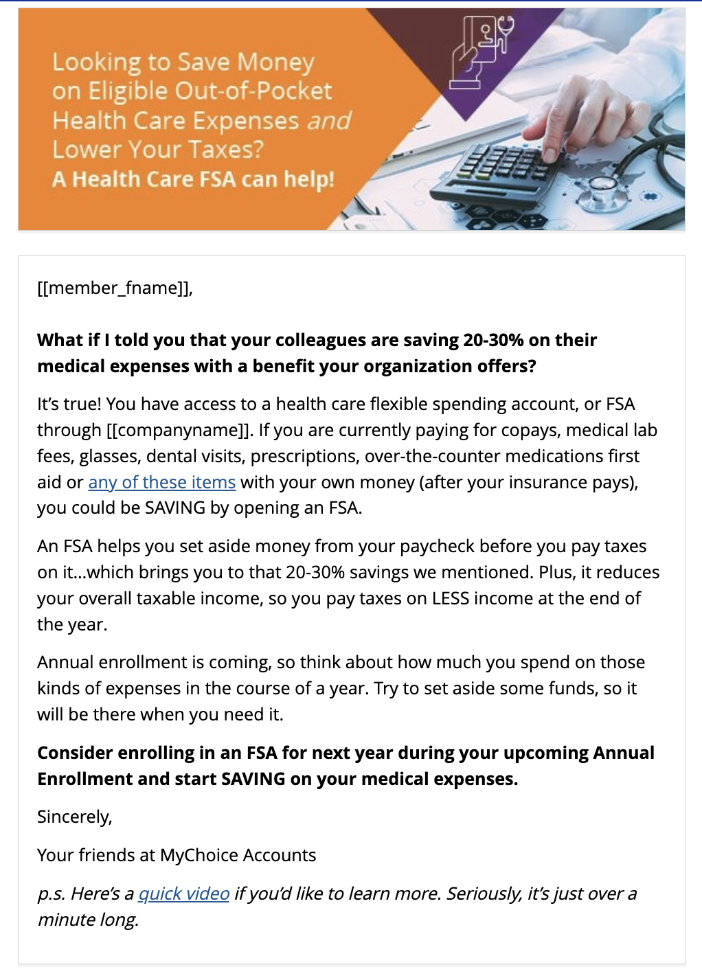

FSA

System Template name: Get ready to enroll in your Health Care FSA

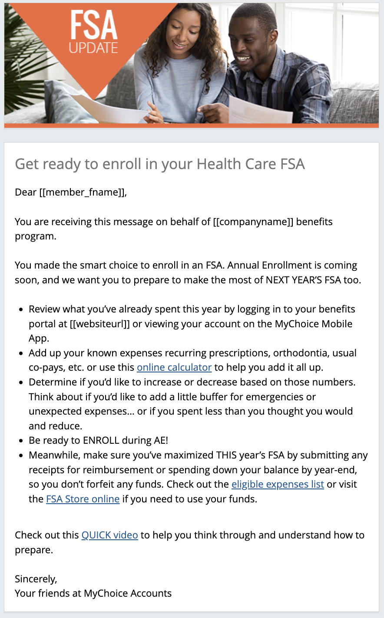

Dependent Care FSA

System Template Name: Save Big with a Dependent Care FSA
For: Employees with dependent 13 or under
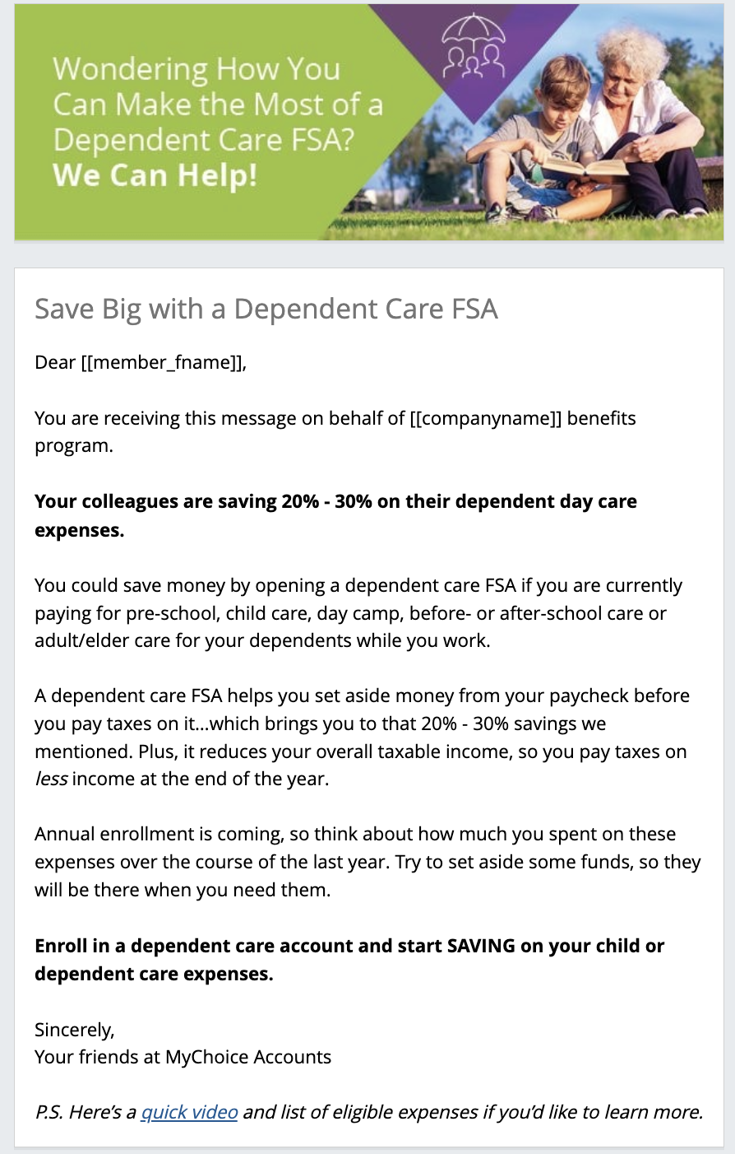

Dependent Care FSA

System Template Name: Get ready to enroll in your Dependent Care FSA
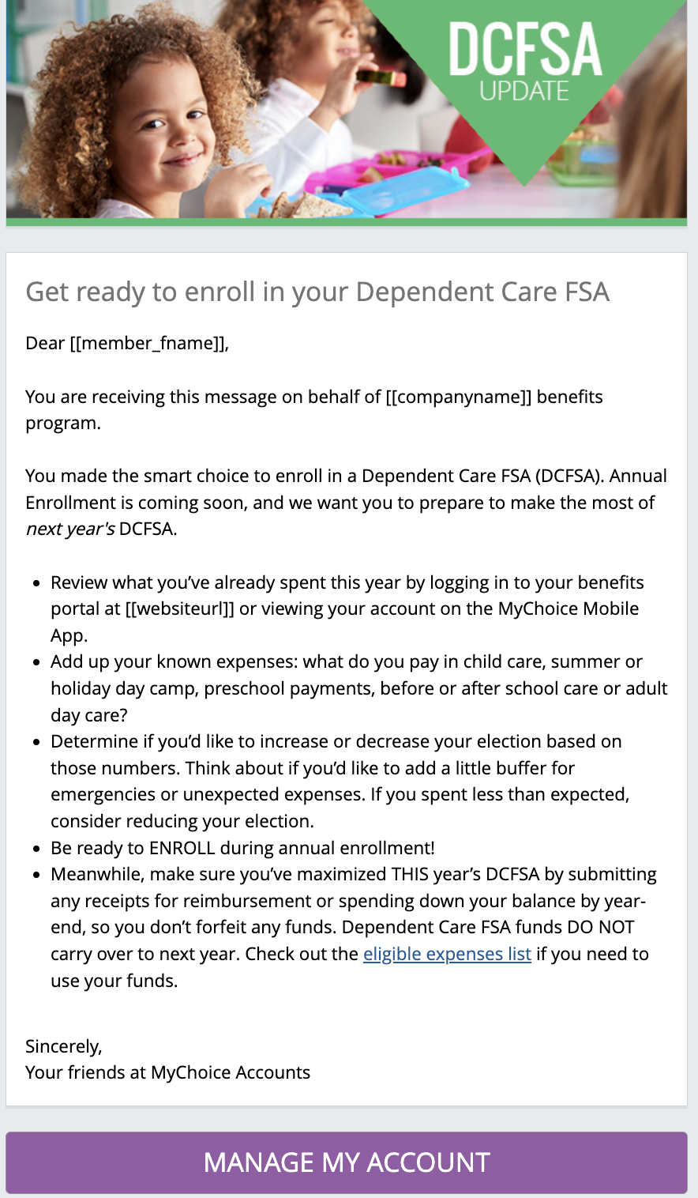

Word Versions w/Banners
for clients to use in their communications
Graphics can be saved by right-clicking and selecting Save As

Word Version: HSA

Unenrolled, eligible for HSA employees – “Don’t Miss Out on Savings”

Send date: -3 weeks until AE//Week of AE

Subject: Don’t miss out on HSA Savings

Dear [[member_fname]],

What if I told you that your colleagues are saving 20-30% on their medical expenses AND saving for retirement with a benefit your organization offers?
It’s true! When you are enrolled in a high deductible health plan, you are eligible to open a health savings account (HSA).
If you are currently paying for copays, medical lab fees, glasses, dental visits, prescriptions, over-the-counter medications first aid or any of these items with your own money (after your insurance pays), you could be SAVING by opening an HSA.
An HSA helps you set aside money from your paycheck before you pay taxes on it…which brings you to that 20-30% savings we mentioned. Plus, it reduces your overall taxable income, so you pay taxes on LESS income at the end of the year.
Annual enrollment is coming, so think about how much you spend on those kinds of expenses, or if you have even $25 a month that you could set aside to grow for the future or unexpected medical expense. Your HSA never expires, doesn’t require receipts and is your savings account for life. It’s a win-win-win.
Enroll in an HSA and start SAVING for your future.
Sincerely,
Your friends at MyChoice Accounts
p.s. Here’s a quick video if you’d like to learn more. Seriously, it’s just over a minute long.

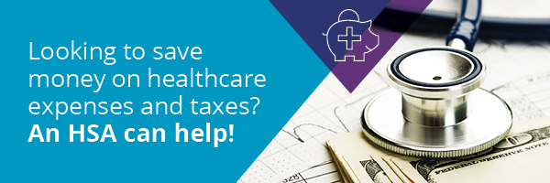

Word Version: HSA

All current members – Get Ready to Enroll

Send date: -3 weeks until AE start date AND week of annual enrollment

Subject: Get ready to enroll in HSA
Dear [[member_fname]],

You made the smart choice to enroll in an HSA. Annual Enrollment is coming soon, and we want you to prepare to make the most of next year’s HSA too.
HSAs provide a safety net for you if you need to cover your health plan out-of-pocket costs (deductible), unexpected medical expenses, or regular medical needs. But the great thing about your HSA is that if you don’t need to use your funds, you can save them year over year. The HSA is your account and never expires.
- Think about your election for the upcoming year. The IRS allows up to $4,400 for single coverage or $8,750 for family coverage in 2026.
- If you are age 55 or over, you can add an additional $1,000 to your annual election if you choose.
- You don’t have to elect the maximum, but it’s a good idea to set some funds aside pre-tax to save or if you need to spend.
- When you make your benefits decisions during annual enrollment, simply put in the amount you’d like to set aside for next year.
Need a refresher on your HSA benefits? Check out this page.
Sincerely,
Your friends at MyChoice Accounts


Word Version: FSA

Employees who are NOT enrolled – Start Saving in 2026!
Send date: -3 weeks until AE start date + Week of AE date (2 emails)
Subject: Consider enrolling in a Health Care FSA during Annual Enrollment
Dear [[member_fname]],
What if I told you that your colleagues are saving 20-30% on their medical expenses with a benefit your organization offers?
It’s true! You have access to a health care flexible spending account, or FSA. If you are currently paying for copays, medical lab fees, glasses, dental visits, prescriptions, over-the-counter medications first aid or any of these items with your own money (after your insurance pays), you could be SAVING by opening an FSA.
An FSA helps you set aside money from your paycheck before you pay taxes on it… which brings you to that 20-30% savings we mentioned. Plus, it reduces your overall taxable income, so you pay taxes on LESS income at the end of the year.
Annual enrollment is coming, so think about how much you spend on those kinds of expenses in the course of a year. Try to set aside some funds, so they will be there when you need them.
Enroll in an FSA and start SAVING on your medical expenses.
Sincerely,
Your friends at MyChoice Accounts
p.s. Here’s a quick video if you’d like to learn more. Seriously, it’s just over a minute long.
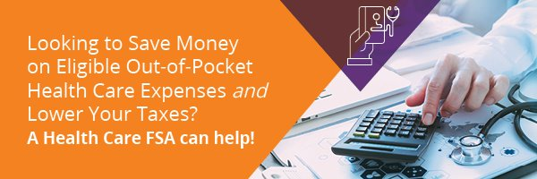

Word Version: FSA

All current members– Get Ready to Enroll

Send date: -3 weeks until AE start date AND week of annual enrollment
Subject: Get ready to enroll in your Health Care FSA
Dear [[member_fname]],

You made the smart choice to enroll in an FSA. Annual Enrollment is coming soon, and we want you to prepare to make the most of next year’s FSA too.
- Review what you’ve already spent this year by logging in to your benefits portal at [[websiteurl]] or viewing your account on the MyChoice Mobile App.
- Add up your known expenses – recurring prescriptions, orthodontia, usual co-pays, etc. or use this online calculator to help you add it all up.
- Determine if you’d like to increase or decrease based on those numbers. Think about if you’d like to add a little buffer for emergencies or unexpected expenses… or if you spent less than you thought you would and reduce.
- Be ready to ENROLL during AE!
- Meanwhile, make sure you’ve maximized THIS year’s FSA by submitting any receipts for reimbursement or spending down your balance by year-end, so you don’t forfeit any funds. Check out the eligible expenses list or visit the FSA Store online if you need to use your funds.
Check out this quick “how to plan” video to help you think through and understand how to prepare.
Sincerely,
Your friends at MyChoice Accounts


Word Version: DCFSA

DCFSA: Employees who are NOT enrolled – Start Saving in 2026!

Send date: -3 weeks until AE start date + Week of AE date (2 emails)

Subject: Consider enrolling in a Dependent Care FSA during Annual Enrollment

Dear [[member_fname]],

What if I told you that your colleagues are saving 20-30% on their dependent day care expenses with a benefit your organization offers?

It’s true! You have access to a dependent care flexible spending account (also known as a dependent care account plan). If you are currently paying for pre-school, child care, day camp, before- or after-school care or adult/elder care for your dependents while you work, you could be SAVING by opening an FSA.

A dependent care FSA helps you set aside money from your paycheck before you pay taxes on it…which brings you to that 20-30% savings we mentioned. Plus, it reduces your overall taxable income, so you pay taxes on LESS income at the end of the year.

Annual enrollment is coming, so think about how much you spend on those kinds of expenses in the course of 2024. Try to set aside some funds, so they will be there when you need them.

Enroll in a dependent care account (DCFSA) and start SAVING on your child or dependent care expenses.

Sincerely,
Your friends at MyChoice Accounts

p.s. Here’s a quick video and list of eligible expenses if you’d like to learn more.


Word Version: DCFSA

All current members– Get Ready to Enroll

Send date: -3 weeks until AE start date

Subject: Get ready to enroll in your Dependent Care FSA
Dear [[member_fname]],

You made the smart choice to enroll in a Dependent Care FSA (DCFSA). Annual Enrollment is coming soon, and we want you to prepare to make the most of NEXT YEAR’S DCFSA too.
- Review what you’ve already spent this year by logging in to your benefits portal at [[websiteurl]] or viewing your account on the MyChoice Mobile App.
- Add up your known expenses – what do you pay in childcare, summer or holiday day camp, preschool payments, before or after school care or adult day care?
- Determine if you’d like to increase or decrease based on those numbers. Think about if you’d like to add a little buffer for emergencies or unexpected expenses…or if you spend less than you think you did and reduce your election.
- Be ready to ENROLL during AE!
- Meanwhile, make sure you’ve maximized THIS year’s DCFSA by submitting any receipts for reimbursement or spending down your balance by year-end, so you don’t forfeit any funds. Dependent Care FSA funds DO NOT carry over to next year. Check out the eligible expenses list if you need to use your funds.
Sincerely,
Your friends at MyChoice Accounts


Setting up action manager rules
Benefitsolver > Client > Benefits > Action Manager > OnDemand Actions tab
To add a new OnDemand Action, Click +New OnDemand Action.
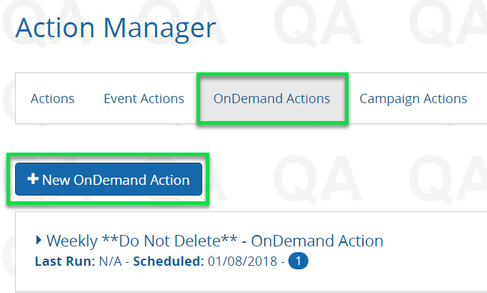
Select Audience
1. In the Step 1 tab, select the admin or member audience for the OnDemand Action. There are three options: Select MEMBERS
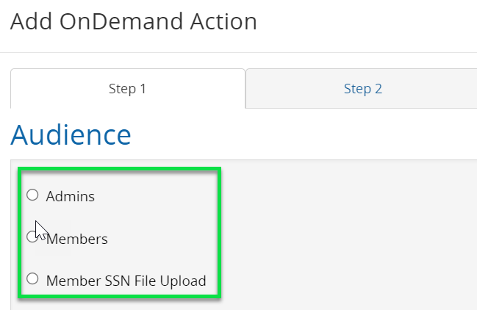
2. In the audience tab, use the ELECTION condition.
3A. Re-enrollment reminders: members already have an HSA and we’d like to remind them to go in and update or review their election. They get a “Get Ready to Enroll” type of reminder.
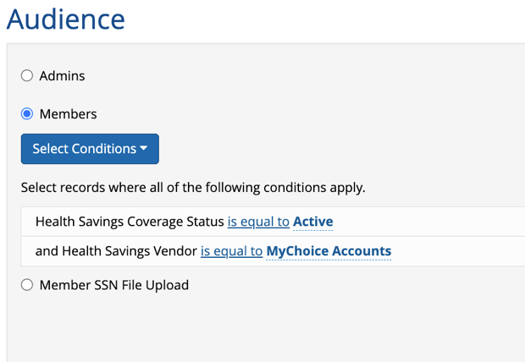

Conditions
Election = Active
Benefit Status = Active (no COBRA)
Employment Status = Full-time
HSA Vendor = MyChoice Accounts*

*This is best practice, but please review settings and make sure this aligns with your settings for your client.

3. B. For non-enrollees – enrolled in the PPO (FSA) or HDHP (HSA) and eligible, but not currently enrolled
Best practice will be to run a report in build a report, validate the data, and upload the SSN list to an On Demand Action. You might get inconsistent results with JUST using conditions in Action Manager.
*Additionally, there could be some variance as members MIGHT elect a different health plan that would make them eligible for the “opposite” account. Be sure to discuss with your client. For instance, someone enrolled in the PPO might elect the HDHP for 2026. Of course, they’ll be offered the right account during enrollment.

Medical Coverage Status = Active
Employment Status = Full-time
Benefit Status = Active (not termination or retiree)
Health Savings Status or Flex Savings Status = waived

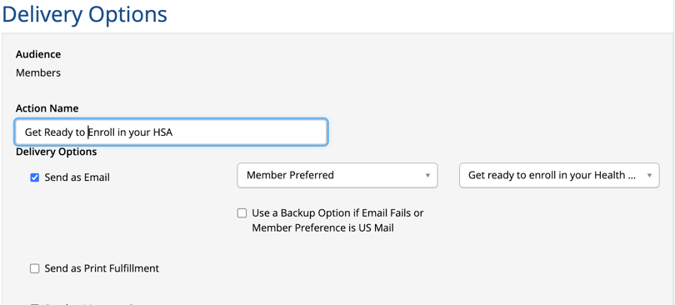

Delivery Options:
- Send as email
- Member preferred email address
- Name of system template

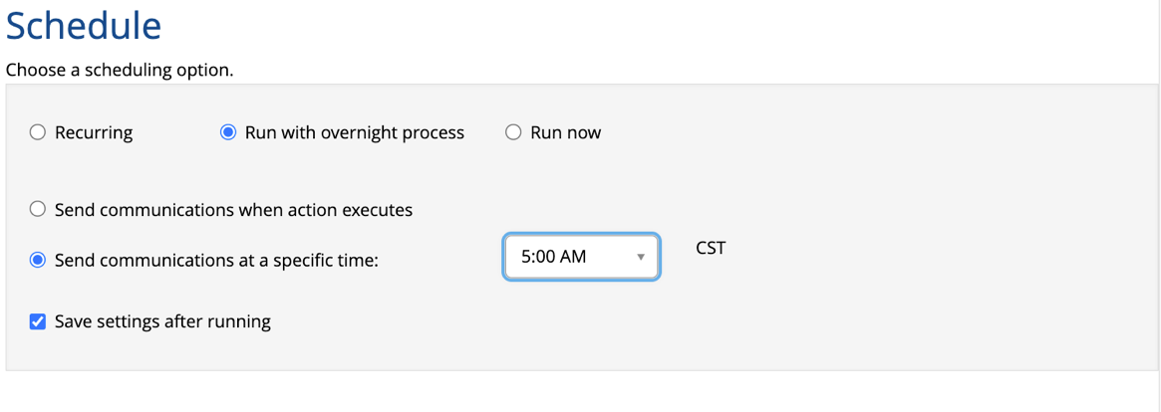

Schedule as usual/needed for best delivery and volume of emails.

Review the Action Summary and make sure the estimated number of recipients = the number of expected recipients. (for re-enroll reminder, does it roughly match the number of members currently enrolled? If not, review your conditions.)

You can check this number by running a report with the same conditions and spot-checking to make sure it’s bringing back the right members.

