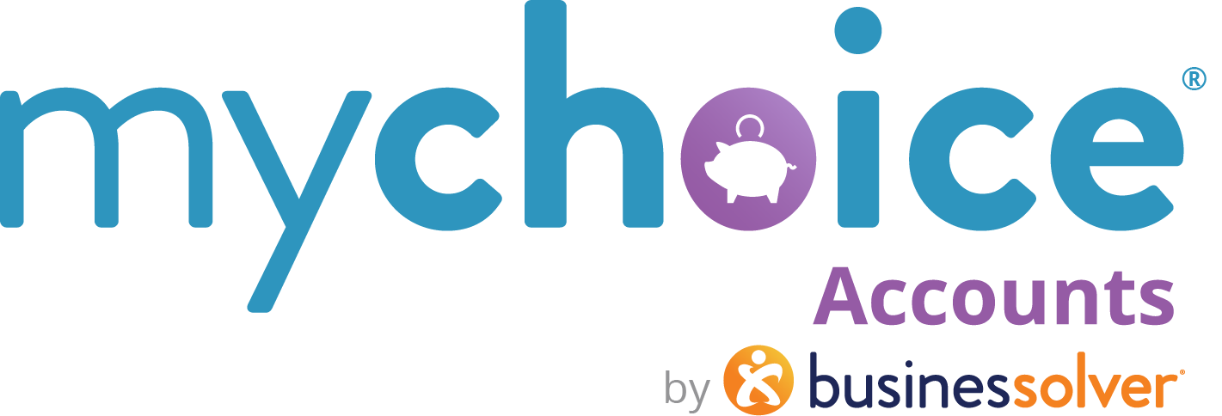

Retiree Health Reimbursement Accounts (or arrangements)
RHRAs (RMA – Retiree Medical Account)

How to use this document:
- If you need to populate a benefits guide, web page, or virtual benefits fair, feel free to pull the relevant copy from this guide.
- Items that are client-level/client-specific plan designs are marked in yellow. Ensure your client-specific information is updated in those fields.

Retiree HRAs vary significantly by employer. Please adjust the template copy as needed to reflect the eligible expenses your company has determined.
Retiree HRAs

What is an Retiree HRA {RMA, plan name}?
Your Retiree HRA is sponsored by {insert company name}. It is an account set up to help you cover health care related expenses.
You have ${XXXX} per year to use for out-of-pocket medical expenses. Here are some of the items and services you can pay for with your HRA:
- Medicare premiums
- Medigap
- COBRA
- Individual health, dental, vision insurance premiums
- Long-term care insurance premiums

(for non-carded RHRA accounts)
How do I access my RHRA funds?
Use your out-of-pocket funds for any eligible expense, and easily create a claim for reimbursement.
Pro-tip: For faster reimbursements, go to Manage and Bank accounts and add your banking information into our secure portal, and we will send your reimbursements directly into your account.

- Log in to your benefits website at {URL} or into your MyChoice Mobile App. Select MyChoice Accounts online or Accounts in the mobile app.
- Select Claims and Submit Claim and fill in the required fields.
- Determine whether you would like to reimburse yourself for an expenditure or submit a payment directly to a provider (to pay a bill, for example).
- Provide documentation of your expense, ensuring that you include the following information:
  - Name of purchaser/recipient of service
  - Date of purchase/service
  - Name of item or service
  - Retailer or provider name
  - Amount paid for purchase/service
- Follow the directions in the claim interface to upload the documentation to your claim.
- Select Review claim to see your request overview and select Submit Claim to finalize.
- You will receive your reimbursement within 5-10 business days if you have submitted everything required.

How do I set up a recurring claim schedule for a monthly expense?
- Log in to your benefits website at {URL} or into your MyChoice Mobile App. Select MyChoice Accounts online or Accounts in the mobile app.
- Select Claims and Submit Claim.
- Determine whether you would like to reimburse yourself for an expenditure or submit a payment directly to a provider (to pay a bill, for example).
- Fill in the required fields according to your expense. Under “reimbursement,” select Recurring Schedule Reimbursement, then select the reimbursement frequency (monthly or weekly), and input your start and end dates.
- Provide documentation of your expense, ensuring that you include the following information:
  - Name of purchaser/recipient of service
  - Date of purchase/service
  - Name of item or service
  - Retailer or provider name
  - Amount paid for purchase/service
- Follow the directions in the claim interface to upload the documentation to your claim.
- Select Review claim to see your request overview and select Submit Claim to finalize.
- You will receive your reimbursement within 5-10 business days if you have submitted everything required.

