Member FSA Webinar Promotion and Details

MyChoice Accounts is hosting an all-FSA member webinar on

February 12, from 1 – 1:45 pm CT.

Member/Attendee Registration: FSA Owner’s Guide Webinar.

This event will be for any member enrolled in a healthcare or limited purpose FSA. Client admins are also welcome to attend.

We’ll cover:
- What’s included and how an FSA works.
- Simple ways to pay for eligible expenses.
- How to submit claims and documentation quickly and easily.

Format: Live Teams Webinar – with Q & A and team to answer questions; recorded to provide to employees via Benefitsolver or direct video link

Sign up: Pre-Registration to help us gauge attendance and to provide an hour-before reminder to registrants.

How to Promote
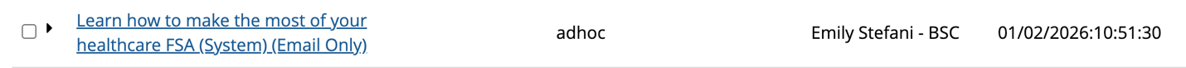
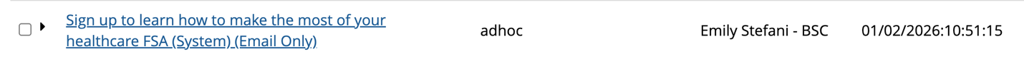
- System Emails: There are system emails available if you would like to work with your CSL to deploy those to active FSA members.

- Use Copy or Share Link: Or, you are welcome to share the registration link and/or use the Word copy below.

https://events.teams.microsoft.com/event/e59b350d-285c-49a7-880a-1dd04aea9d24@074bbbca-91df-4ac1-89ec-37a6e55bef47

Email 1
Timing: three weeks out (week of 1/19)
Subject: Learn how to make the most of your [healthcare FSA]
Hello:
Are you using your [healthcare flexible spending account (FSA)] to its full potential? Join this webinar from the team at MyChoice Accounts for practical information and tips on using an FSA—and the chance to win a gift card!
Learn all about:
- What’s covered and how an FSA works.
- Easy ways to pay for eligible expenses.
- How to submit claims and documentation.
Date: February 12, 2026
Time: 1 – 1:45 pm CT (30 minutes + 15 minutes for questions)
Reserve your spot and make sure you know how to make every FSA dollar count.

Register here:
FSA Owner’s Guide Webinar.
Attend the webinar and we’ll enter you in a drawing for a $50 gift card.
We hope you take advantage of this opportunity to learn more about FSAs.

**********************************************************************

Email 2
Timing: one week out (week of 2/02)
Subject: Have you signed up to learn how to make the most of your FSA?
Hello:
The team at MyChoice Accounts is gearing up for an informational webinar that will help you increase your FSA knowledge so you can save money on your healthcare costs.
Join their upcoming webinar to learn more about:
- What’s included and how an FSA works.
- Simple ways to pay for eligible expenses.
- How to submit claims and documentation quickly and easily.

Date: February 12, 2026
Time: 1 – 1:45 pm CT (30 minutes + 15 minutes for questions)
Don’t miss this chance to learn how to make every FSA dollar count.

Register here: FSA Owner’s Guide Webinar.

Plus, if you join us, you’ll be entered to win a $50 gift card.

P.S. Can’t attend? Just register and the team at MyChoice Accounts will send you the recording.

